**VA Northeast Ohio Healthcare System**

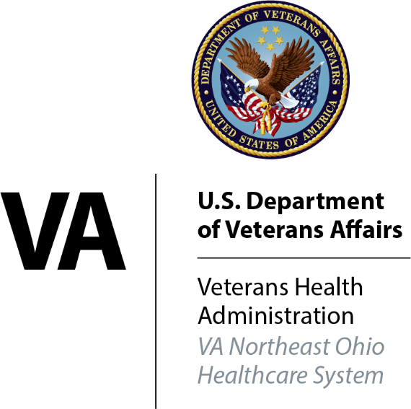

**Essential**

**Documents**

**Binder**

**Essential Documents**

for

Study Title

Investigator

Study Site

Sponsor

**Essential Documents Table of Contents**

Research and Development Committee Approval Letter

Protocol & Amendments/Research Plan

Operations Manual

Approved Case Report Forms

IRB Approved Consent Forms / Information Provided to Subjects

Subject Log / Clinic Lists in CPRS

IRB Submissions / Notifications / Approvals

LSI cIRB Submissions/Approvals

PI/SC cIRB Submissions/Approvals

Unanticipated Problems/Serious Adverse Events / Safety Reports

Notes-to-File

Investigator Responsibilities/Agreements (with Sponsor, Institution, FDA, etc.)

Study Site Personnel (Signatures, Qualifications, Training)

Site-Sponsor Correspondence

Conference Call Minutes

Newsletters

Investigator Brochure (DIR)/ VA Form 10-9012

Investigational Products (Accountability, Handling, Pharmacy)

Laboratory

Subject files

Visitor log

*Forms and Tools:*

*Items used in binder may be obtained from the VA Northeast Ohio Healthcare System website*

<http://www.clevelandvaresearch.org/>

*References:  
 VHA Handbook 1200.05  
 VHA Handbook 1108.04  
 Good Clinical Practice: Consolidated Guidance, (ICH E6), Section 8.0*

**Essential Documents Directory**

*"Essential Documents are those documents that individually and collectively permit evaluation of the conduct of a trail and the quality of the data produced"*

*FDA/ICH*

This binder serves as a repository and directory to all study documents and records in the Investigator File for this clinical study. Should the need arise, contents of this binder can be expanded to other binders of folders (provided by the site) in any manner that maintains orderly organization of the file and assures ready access to all documents.

**This Directory is to be updated throughout the**

**study, and must be complete and accurate when**

**archived at the close of the Study.**

**Complete the following at end of study:**

*I have reviewed the Investigator Study File and found it to be complete and accurate.*

____________________________________ _________________

Investigator Signature Date

**Research & Development Committee Approval Letters**

* Research and Development Committee initial approval letter
* Research and Development Committee annual renewal letters

*STANDARDS FOR MAINTAINING THIS SECTION*

**Research & Development Committee Approval Letters**

* Maintain a paper copy of the initial Research and Development Approval letter this letter must be available in the Regulatory Binder.
* Maintain a paper copy of all Research and Development Annual renewal letters in the Regulatory Binder.

**Protocol, Research Plan & Amendments**

* **Study Protocol/Research Plan**
* **Protocol Amendments/Research Plan Amendments**

List all protocols/research plans, protocol amendments, and/or research plan amendments, received during the study. Identify documents by date and/or version number or insert sponsor-generated lists of these documents.

|  |  |
| --- | --- |
| **Research Plan Version #** | **Date of Research Plan** |
|  |  |
|  |  |
|  |  |
|  |  |
|  |  |
|  |  |

|  |  |
| --- | --- |
| **Protocol Version#** | **Date of Protocol** |
|  |  |
|  |  |
|  |  |
|  |  |

***TO CONSERVE SPACE, PROTOCOLS MAY BE STORED IN SEPARTATE BINDERS***

*STANDARDS FOR MAINTAINING THIS SECTION*

**Protocol & Amendments**

* All versions of the study protocol and amendments used in this study must be available in the Investigator Study File at all times.
* Maintain a paper copy of the current version of the protocol to assure immediate access to current documents at all times.
* Maintain outdated protocols either as hardcopy or in an electronic research file maintained on a VA server.
* At the end of the study, all versions and updates must be archived in the Investigator Study File, either as hardcopy or in an electronic research file maintained on a VA server.

**Operations Manual**

* Operations Manual (procedure manual) and updates
* Operations Memos
* Other written instruction issued by Sponsor

Operations Manual - a complete cumulative record of manuals and updates will be maintained by:

**□** Maintaining printed copies

**□** Maintaining electronic copies in your research file on a VA server

(s:\drive, m:\drive, share point, site provided by the sponsor)   
**□** Other___________________________________

CRFs - A complete record of all CRFs used in this study will be maintained by:

**□** Maintaining printed copies

**□** Maintaining electronic copies in your research file on a VA server

(s:\drive, m:\drive, share point, site provided by sponsor)

**□** Other___________________________________

**Check all that apply**

***TO CONSERVE SPACE, OPERATIONS MANUAL AND UPDATES MAY BE STORED IN SEPARTATE BINDERS OR ELSEWHERE OUTSIDE OF THIS BINDER***

*STANDARDS FOR MAINTAINING THIS SECTION*

**Operations Manual**

* All versions of the study protocol/research plan and amendments used in this study must be available in the Investigator Study File at all times. In CSP studies, a cumulative listing of all revisions is provided to the Investigator with each update.
* Maintain a paper copy of the current version of the protocol/research plan to assure immediate access to current documents at all times.
* All versions of each CRF used in the study must be kept in the Investigator Study File or be otherwise accessible at all times. Each CRF must be readily identifiable by version date or other identifying system that allows determination of period of use.
* Maintain outdated protocols either as hardcopy or in an electronic research file maintained on a VA server (s:\drive, m:\drive, share point, site provided by sponsor).
* At the end of study, all versions and updates of the Operations Manual and CRFs must be archived in the Investigator Study File, either in hardcopy or electronic form.**IRB-Approved Subject Consent Forms and Other Information Provided to Subjects**
* Record of approved IRB consent form versions
* Consent Forms - Unsigned copy of each version approved by the IRB
* HIPAA Forms - Unsigned copy of each version approved by the IRB
* Advertisements - all recruitment documents approved by the IRB
* Other written information provided to subjects as approved by the IRB

*STANDARDS FOR MAINTAINING THIS SECTION*

**Consent Forms/Information Provided to Subjects**

* This section is intended to provide an historical record of all IRB-approved consent forms and other documents provided to subjects. NOTE: IRB review and approval is required for any printed information given to subjects and any recruiting materials used in the study.
* File in this section the IRB-approved consent and HIPAA authorization forms and any associated informational materials to be presented to subjects. IRB-approved recruitment materials should be filed in this section.
* File only the final approved document(s), one copy of each version approved during the study. File the correspondence concerning these documents in the IRB Correspondence Section.
* Initiate a ***Record of Approved Consent Form Versions***
  + Version (Document Control) - record the version number, date or other unique identifier that has been applied to the form
  + Date received from IRB - record the date that the newly approved consent form is received back from the IRB. This date, rather than the date of IRB approval, is the date the Investigator will be expected to start using the form.
  + Document reason for revision.
  + Re-consent required? If “yes,” re-consent all active subjects; if “no” use for all future subjects.
* Initiate a ***Subject Consent - Re-consent Tracking Log***, if necessary
  + Re-consenting current subjects - if the revised form contains information that may affect subject's willingness to continue, the information must be communicated to current active subjects. If re-consent is the method chosen to communicate the new information, this consenting must occur at the first opportunity, i.e., next scheduled visit, or sooner if necessary, e.g., special visits, mail, etc.
* Outdated consent and HIPAA authorization forms should be retained for historical purposes should be defaced with a note such as ***"OBSOLETE- DO NOT USE"*** to prevent inadvertent use of an expired form.
* All signed informed consents should be filed in the **Subject Consent Forms Master File.**

**RECORD OF APPROVED CONSENT FORM VERSIONS**

Study Title:

Investigator:

Study Site:

Sponsor:

|  |  |  |  |  |
| --- | --- | --- | --- | --- |
| **VERSION** *(per your site convention)* | **IRB Approval / Expiration dates** | **Date received from IRB** | **Reason for revision\*** | **Necessary action\*\*** |
|  |  |  | Initial approval | Use for future subjects |
|  |  |  |  |  |
|  |  |  |  |  |
|  |  |  |  |  |
|  |  |  |  |  |
|  |  |  |  |  |
|  |  |  |  |  |
|  |  |  |  |  |
|  |  |  |  |  |
|  |  |  |  |  |
|  |  |  |  |  |
|  |  |  |  |  |
|  |  |  |  |  |
|  |  |  |  |  |
|  |  |  |  |  |
|  |  |  |  |  |
| **\* Reasons**   * Protocol change * New risks identified * Annual re-approval (text unchanged) * Other | | | **\*\* Actions**   * Use for future subjects only * Re-consent all active subjects | |

**Subject Log/Clinic Lists IN CPRS**

* List of all subjects signing consent with date of enrollment or reason not enrolled

*STANDARDS FOR MAINTAINING THIS SECTION*

**Subject Log/Clinic Lists in CPRS**

* Initiate a SUBJECT LOG that contains the following Information:
  + Subject ID #
  + Consent Date
  + Enrollment/Randomization Date
  + Randomization #, if applicable
  + Date Terminated
  + Reason not Randomized or Terminated
  + Last four of Subject social security
* Any spreadsheet or log providing at least the minimal information listed on the attached subject log example is acceptable. The log should be updated regularly during the study and upon study closure.
* Subject lists in CPRS - review instructions for creating Clinic Lists in CPRS for study subjects. Grouping study subjects in this manner allows use of certain efficiency features available in CPRS:
  + CPRS can be programmed to send study staff instant notice of ER, urgent care and hospital admissions of study subjects
  + CPRS can be programmed to automatically forward progress notes by team members for Investigator acknowledgement (keeps Investigator informed, documents Investigator involvement)
  + This list also enables the institution to provide medical records access limited to patients signing consent and authorizing sponsor representatives to review medical records.

**SUBJECT LOG**

*(list all subjects signing consent)*

Investigator: ____________________ Project: ______________________

Study Site: ______________________ Sponsor: _____________________

|  |  |  |  |  |
| --- | --- | --- | --- | --- |
| **Screening Number** | **Consent Date** | **Randomization Date**  **and Number**  *(or reason not randomized)\** | **Date Terminated** | **Reason Not Randomized or Terminated** |
|  |  |  |  |  |
|  |  |  |  |  |
|  |  |  |  |  |
|  |  |  |  |  |
|  |  |  |  |  |
|  |  |  |  |  |
|  |  |  |  |  |
|  |  |  |  |  |
|  |  |  |  |  |
|  |  |  |  |  |
|  |  |  |  |  |
|  |  |  |  |  |
|  |  |  |  |  |
|  |  |  |  |  |
|  |  |  |  |  |
|  |  |  |  |  |
|  |  |  |  |  |
|  |  |  |  |  |
|  |  |  |  |  |
|  |  |  |  |  |
|  |  |  |  |  |

*\*Specify the eligibility criterion failed or other reason subject not randomized*

**VA Electronic Medical Records**

*Clinic Lists in CPRS for Study Subjects*

These instructions provide user directions to create a clinic list in CPRS.

The benefits of this practice include:

• **Clinic lists allow the user to open the medical record system with their specific subjects listed in one group. This is an efficient mechanism for the user to retrieve the records of their study participants.**

**• Clinic lists can be programmed to forward notes by study team members to the Investigator for acknowledgement. This assists the study coordinator in keeping the PI informed as well as documenting Investigator oversight.**

**• Clinic lists can be programmed to notify study personnel of subject admissions, ER or Urgent Care visits to the facility. This permits early detection of potential serious adverse events.**

**• Clinic lists can facilitate research monitors/auditors limited access to a particular group of study participants records; more specifically read only viewing limited to those subjects that have signed an informed consent granting sponsor representatives permission to review their medical records.**

1. Under the Tools dropdown menu select Personal Preference. At some sites, Options appear in place of Personal Preferences.

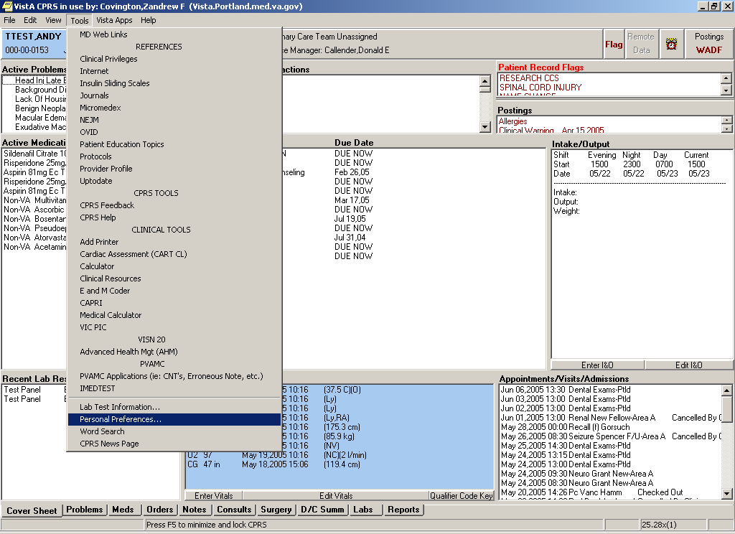

2. Choose the Lists/Teams Tab on the Personal Preferences screen.

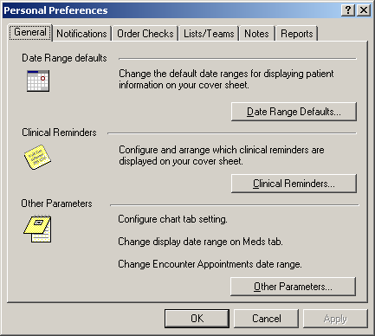

3. Select the Personal List Button:

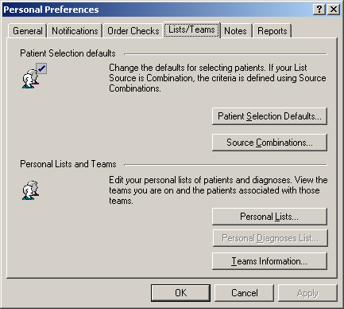

4. Click on the new list button and enter a name for your personal list.

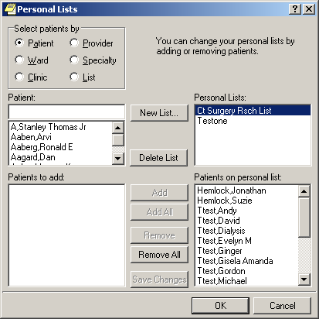 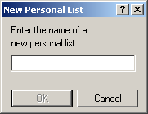

5. Click on the Patient button and begin to enter patients using their last name, first name or first initial of their last name and last four of their SSN. Select the Patient to add to the Patient to Add list.

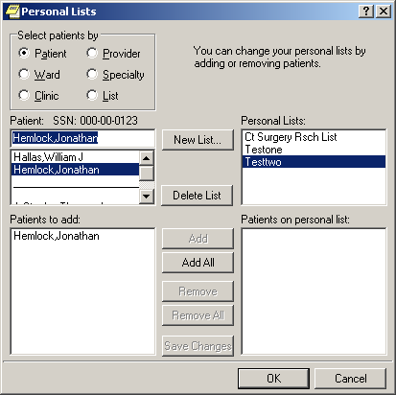

6. As you fill the Patient to Add list when you are finished with the last patient click on the Add All button to move the patients to the Patients on personal list field.

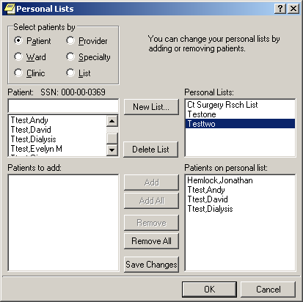

7. When you are finished adding patients, click on the OK button. Note to edit your list follow the steps to get this point (that is you can select your list) and select the patients your want to remove from your list.

8. To select your list, go to the Patient Selection Screen. Look for the Team/Personal List radio button and type in the name of your list.

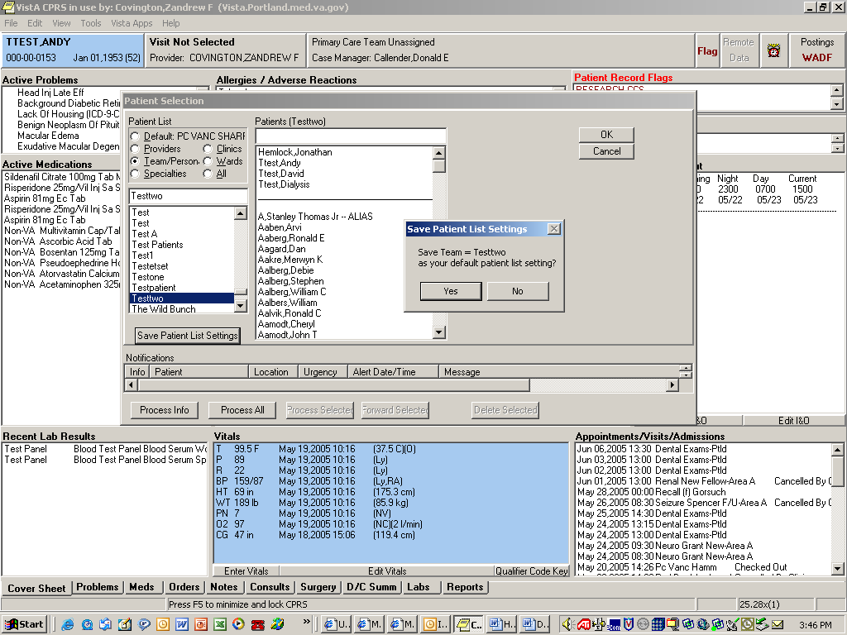

9. Select the Save Personal List Setting button and select yes. Then select one of the patients on the list and go into their chart to lock the setting.

Notifications are used to inform the study staff about a subject’s medical activity between study visits and are an excellent mechanism to identify adverse events and serious adverse events. Once the parameters for notifications are established, they will appear for each subject on the study’s Clinic List under “Notifications”, which is located on the “Patient Selection” page in CPRS.

To set up notifications:

1. Under the Tools dropdown menu select Personal Preference or Options.

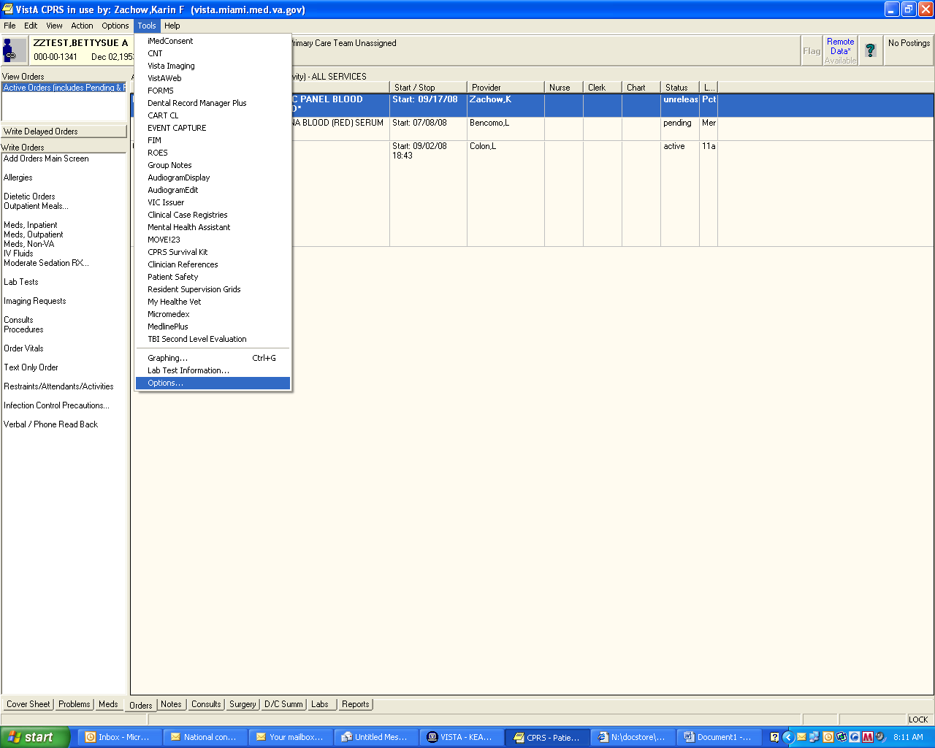

2. Choose the Notifications Tab on the Personal Preferences (or Options) Screen



3. The list of notifications will appear. Check off those notifications which will assist in identifying potential adverse events/serious adverse events (e.g., abnormal lab results, admission, consults, etc). Note that there are some mandatory notifications. Even if they are not pertinent to the study’s needs, they will appear anyway.

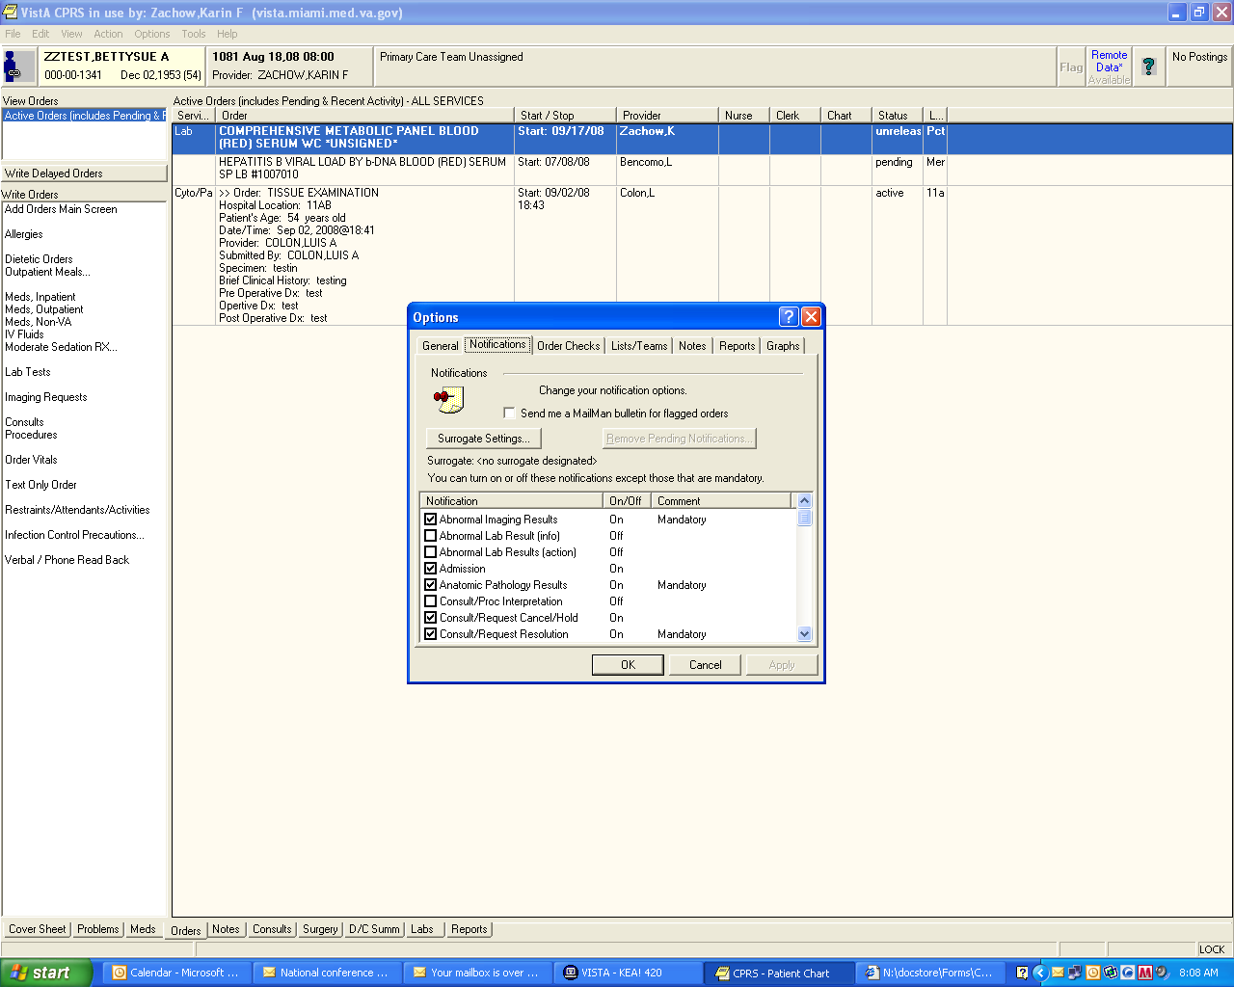

4. Select “OK” to finalize the notifications which will appear for the clinic listing.

5. Return to the “Select Patient” screen to view the list’s notifications.



Below is a magnified notifications screen. If there were any notifications, the patient(s) would be listed accompanied by a message which is the actual notification (e.g., abnormal glucose 390 9/12/08)



**IRB Submissions/Notifications/Approvals**

* IRB Submission Tracking Log
* IRB membership lists for the duration of the study or documentation of Federal-wide Assurance (FWA), i.e., certification number and expiration date
* Documentation of IRB submissions and resulting approvals and acknowledgments including the following:
  + IRB approval of protocol, amendments to protocol, subject information sheets, consent form(s), recruitment tools, study personnel
  + IRB periodic approval to continue the study
  + Periodic progress reports submitted to the IRB
  + Required notifications and reports, e.g., notification of study closure
  + Reports of unanticipated problems to the IRB
  + Reports of adverse events and safety information from the sponsor - see section labeled SERIOUS ADVERSE EVENTS/ SAFETY REPORTS following this section
  + Other submissions as required by the VA or sponsor

***THE USE OF SEPARATE BINDER(S) FOR THIS SECTION MAY BE NECESSARY***

*STANDARDS FOR MAINTAINING THIS SECTION*

**IRB Submissions/Notifications/Approvals**

* Retain complete copies of all correspondence to and from the IRB.
* A cover letter or equivalent should accompany each submission to the IRB to clearly identify purpose of submission and all items included in the submission. If submissions are completed and submitted electronically, print paper copies to file in this section. Print and file IRB responses as soon as they are posted.
* Stamp the date of receipt on all correspondence received from IRB. Mark only the IRB cover letter, not the official document, e.g., do not stamp a consent form; stamp the approval letter.
* IRB Submission Packets – develop “packets” of materials related to each IRB submission. To form a packet, retain copies of all items submitted to the IRB and, when received, attach a copy of the IRB response(s) thus creating a complete record of each submission. Each submission packet can be recorded as a line item on the IRB Submission Tracking Log.
* CSP IRB Submission Standard-Any item provided by CSP for submission to the IRB must be submitted by the Investigator within ten working days of receipt or within one working day for high priority actions for which immediate subject notification is required.
* Adverse events must be reported to the IRB in the manner prescribed by the IRB. Know your IRB rules for reporting these events.

*STANDARDS FOR MAINTAINING THIS SECTION (cont.)*

**IRB Submissions/Notifications/Approvals**

* Unanticipated problems involving risks to subjects or others may also require reports to the IRB. Know your IRB rules for reporting unanticipated problems.
* **ALERT**   
  Assure that your Research Compliance Officer (RCO) is made aware of events and problems reported to the IRB as a report must also be sent by the facility to the VA Office of Research Oversight (ORO) when the problem or adverse event is found by the IRB to be:
  + Unanticipated and
  + Serious and
  + Related to research.

**IRB Submission Tracking Log**

Investigator: Project:

Study Site: Sponsor:

|  |  |  |  |  |  |
| --- | --- | --- | --- | --- | --- |
| Document | Document Date | Date Submitted to IRB | Date IRB Approved or Acknowledged | Approval Letter(s) in files | Comments |
|  |  |  |  |  |  |
|  |  |  |  |  |  |
|  |  |  |  |  |  |
|  |  |  |  |  |  |
|  |  |  |  |  |  |
|  |  |  |  |  |  |
|  |  |  |  |  |  |
|  |  |  |  |  |  |
|  |  |  |  |  |  |
|  |  |  |  |  |  |
|  |  |  |  |  |  |

**Serious Adverse Events / Safety Reports**

* **Log of Serious Adverse Events (SAEs*)***
* Documentation of Sponsor and IRB Notification of SAEs
* **Log of Safety Reports & Data Monitoring Committee (DMC) Summaries**
  + Safety reports received from Sponsor
  + DMC summaries received from Sponsor
  + Documentation of IRB notification of both Safety Reports and DMC summaries

**ALERT**   
See section labeled IRB SUBMISSIONS/NOTIFICATIONS/APPROVALS for details.

* Adverse events may require reports to the IRB and/or sponsor. Know your IRB rules for reporting these events. See section labeled SERIOUS ADVERSE EVENTS/SAFETY REPORTS that follows this section.
* Initiate ***Serious Adverse Events Log***.
* Initiate a ***Safety Reports Received from Sponsor Log***.

**SERIOUS ADVERSE EVENTS LOG**

(SAEs occurring at this site)

Investigator: ______________________________________ Project: ________________________________________

Study Site: ______________________________________ Sponsor: ________________________________________

|  |  |  |  |  |  |  |
| --- | --- | --- | --- | --- | --- | --- |
| **Date SAE Occurred** | **Date Learned of Event** | **Subject Identifier** | **Event** | **Study SAE Form Completed**  **(Y/N)** | **Date Reported to Sponsor\*** | **Date Reported to IRB\*\*** |
|  |  |  |  |  |  |  |
|  |  |  |  |  |  |  |
|  |  |  |  |  |  |  |
|  |  |  |  |  |  |  |
|  |  |  |  |  |  |  |
|  |  |  |  |  |  |  |
|  |  |  |  |  |  |  |

*\*If required by the Sponsor (see protocol for Sponsor requirements)*

*\*\*If required by the IRB (see IRB requirements for adverse event reporting, i.e., definitions & timeframes*

**SAFETY REPORTS RECEIVED FROM SPONSOR**

Investigator: _____________________________________ Project: ________________________________________

Study Site: _____________________________________ Sponsor: ________________________________________

|  |  |  |  |  |
| --- | --- | --- | --- | --- |
| **Safety Report**  **ID #** | **Event or**  **Nature of Report** | **Date Received**  **from Sponsor** | **Date Reported**  **to IRB** | **IRB Acknowledged**  **(Y/N)** |
|  |  |  |  |  |
|  |  |  |  |  |
|  |  |  |  |  |
|  |  |  |  |  |
|  |  |  |  |  |
|  |  |  |  |  |
|  |  |  |  |  |

**Notes-To-File**

* Documentation or explanation of unusual events, practices, problems or communications, e.g., inadvertent omissions in completing study procedures.

*STANDARDS FOR MAINTAINING THIS SECTION*

**Notes-To-File**

* Notes-to-File serve to explain unusual events or circumstances such as:
  + Consent problems and irregularities
  + Protocol deviations
  + Drug or device accountability issues
  + Discussions with sponsor for protocol interpretation or guidance
  + Discussions with IRB for interpretation or guidance on IRB rules
  + Patient management issues
  + Unusual site practices in study conduct, file maintenance, etc
  + “anything that needs explaining”
* Format and Content - each Note-To-File must contain certain critical information, i.e., what happened, how it was remedied, and how recurrence will be prevented. Notes-to-File must be signed and dated.
* Where to File – The Note-to-File should be attached to the study document that is addressed or explained by the note. To aid in tracking, copies of all Notes-to-File should also be filed chronologically in this section or recorded on the ***Note-To-File*** Log that follows.
* Reports to IRB – Know your IRB rules for reporting unanticipated problems involving risks to subjects. Problems documented in Notes-to-File may require reporting to the IRB

**Note-To-File:** Study:

Date:

Investigator:

Subject # (if applicable):

**EXPLANATION OF IRREGULARITY**

Check all that apply:

Subject Consent issue

Inclusion/Exclusion criteria not met

Subject in simultaneous interventional studys

Adverse event not reported to Sponsor as required

Adverse event not reported to IRB as required (see local IRB guidelines)

Drug or Device accountability issue

Subject seen or procedure performed, outside the allowed visit window

Required study procedure not completed

Other

(1) Description of irregularity:

________________________________________________________________________________________________________________________________________________________________________________________________________________________________________________________________________________________________________________________________

(2) Remedy for this irregularity (if applicable):

________________________________________________________________________________________________________________________________________________________________________________________________________________________________________________________________

(3) Steps to prevent recurrence (if applicable):

________________________________________________________________________________________________________________________________________________________________________________________________________________________________________________________________

Record of notifying Sponsor (if applicable):___________________________________________

Date Sponsor representative notified:

Name of Sponsor representative contacted:

Study team member contacting Sponsor rep.:

Other parties receiving this Note, e.g., IRB:

Study Coordinator: _____________________Date: _______________________

(Signature)

Investigator: __________________________Date: _______________________

(Signature)  
***File this form with the study document or documents related to the event or issue that prompted this note***

**NOTES TO FILE**

**PROTOCOL:**

**INVESTIGATOR:**

|  |  |  |  |  |
| --- | --- | --- | --- | --- |
| DATE OF NOTE | DESCRIPTION / ISSUE | DATE REPORTED TO IRB*  (OR NA) | DATE DISCUSSED WITH SPONSOR (OR NA) | WHERE THE NOTE IS FILED* |
|  |  |  |  |  |
|  |  |  |  |  |
|  |  |  |  |  |
|  |  |  |  |  |
|  |  |  |  |  |
|  |  |  |  |  |
|  |  |  |  |  |
|  |  |  |  |  |
|  |  |  |  |  |
|  |  |  |  |  |
|  |  |  |  |  |
|  |  |  |  |  |
|  |  |  |  |  |
|  |  |  |  |  |

**IRB NUMBER:**

* The Note-to-File should be attached to the study document that is addressed or explained by the note. It may also be filed in the NOTES-TO-FILE section of the Essential Documents Binder.

**Investigator Responsibility/Agreements**

* Agreements with Sponsor – Investigator Agreement
* Agreements with FDA
* Form FDA 1572 (for drugs and biologics)
* Investigator Signed Agreement (for devices)
* Investigator Disclosure Statements
* Financial Conflicts of Interest
* Professional Conflicts of Interest
* Other Investigator agreements

*STANDARDS FOR MAINTAINING THIS SECTION*

**Investigator Agreements**

* Requirements for formal Investigator agreements, pledges, and disclosures vary among studies and may involve FDA, Sponsor, IRB and institution.
* Documents that may be filed in this section include:
* **Guidance for Industry: Investigator Responsibilities-Protecting the rights, Safety and Welfare of Study Subjects**
  + Investigator Agreement – with sponsor to comply with protocol and other applicable requirements
  + Investigator Agreement – with IRB or Institution to comply with protocol and other applicable requirements
  + FDA Form 1572 Statement of Investigator (drugs & biologics) or Investigator Signed Agreement (devices), if applicable
  + Disclosure Statement(s)
* Documents required for study team members should also be filed in this section.

**Study Site Personnel**

* Site Personnel Signatures/Delegation of Responsibility Log

*STANDARDS FOR MAINTAINING THIS SECTION*

**Study Site Personnel**

* This is a critically important section intended to document:
  + Study team members and the tasks delegated to each
  + Qualifications and training of each team member
* Forming a Study team – Each team member selected by the Investigator represents additional effort in training, supervising, registering with IRB and record keeping, so study teams should be limited in size and composition to that necessary to assure smooth study operations.
* Key Sub-Investigator – At least one sub-investigator must be selected who can function in place of the Investigator during absences.

**SIGNATURES & DELEGATED RESPONSIBILITIES LOG**

* This log is signed by individuals meeting any of the following:
  + listed by name on the Consent Form
  + listed as a team member in the IRB approval document
  + listed on the FDA Form 1572 or equivalent
  + operating under a position description appearing in the Study Personnel Section of the protocol
* Designate as team members only individuals requiring formal study orientation/protocol training. Do not list individuals performing study related tasks in the normal course of their work at the facility unless study specific training is required or the Sponsor specifically directs they be listed. In CSP studies, for example, an EKG technician or phlebotomist typically would not be listed as a team member, but the Research Pharmacist would.
* This log is also used to document the Investigator’s delegation of study tasks. Tasks are to be delegated to qualified individuals in accordance with protocol requirements and applicable state and local scope of practice standards. Decisions requiring higher levels of clinical judgment such as eligibility, termination, adverse event relatedness and medical treatment are to be made by the Investigator or a clinically equivalent designee.

**TRAINING RECORDS**

* Establish and maintain a SIGNATURES & DELEGATED RESPONSIBILITES LOG.
* VA Research mandated training in Good Clinical Practice Human Subjects Protections, (renewed every 2 years) and Research Safety, if applicable. (renewed annually). Confirm Research Service has these documents on file.

**CURRICULUM VITAE AND PROFESSIONAL LICENSURE**

* Current CVs must be maintained for each study team member by the Research Service. CVs should be updated and signed with a date at least every two years.
* Documentation of current professional licensure, if applicable or not a part of VetPro, shall also be maintained in the Research Service.

**SCOPE OF PRACTICE**

* Scope of Practice and Educational Plan for Research Service Investigators and Coordinators is renewed annually. Confirm these documents are maintained in the Research Files.

**CONFLICT OF INTEREST**

* The Conflict of Interest form (COI) must be completed by the PI and Co-I, at the time of initial submission and with each continuing review. Confirm these documents are in the R&DC files and IRB files.

**STUDY MANAGEMENT / INVESTIGATOR OVERSIGHT**

* Periodic Meetings of the Investigator Study Team are highly recommended and should be documented.
* Study team members’ CPRS entries should be forwarded to the Investigator for acknowledgment to document Investigator awareness of study progress and oversight of study conduct.

SITE PERSONNEL

**SIGNATURES & DELEGATED RESPONSIBILITIES**

Investigator: ______________________ Project: ____________________________

Study Site: ________________________ Sponsor: ___________________________

List all study team members, i.e., individuals that require protocol training/orientation to perform tasks and procedures required for this study. Initiate a ***Study Team Member Training Log*** for each member listed above (except pharmacist).

|  |  |  |  |  |  |  |  |
| --- | --- | --- | --- | --- | --- | --- | --- |
| **NAME (PRINT OR TYPE)** | | **Title or Position** | **Task* Codes** | | **SIGNATURE** | **INITIALS** | Dates **(OF WORK ON STUDY)** |
| Codes | **PI’s  Initials |
|  | | Investigator |  | NA |  |  | From:  To: |
|  | | Coordinator |  |  |  |  | From:  To: |
|  | | Sub-investigator |  |  |  |  | From:  To: |
|  | |  |  |  |  |  | From:  To: |
|  | |  |  |  |  |  | From:  To: |
|  | |  |  |  |  |  | From:  To: |
|  | |  |  |  |  |  | From:  To: |
|  | |  |  |  |  |  | From:  To: |
| **Delegated** Responsibilities* | A = Make eligibility / termination decisions E = Evaluate adverse events (occurrence/severity) Other Study Tasks  B = Obtain informed consent F = Evaluate adverse events (cause/relatedness) I = _________________________  C = Direct medical care of subject G = Prescribe study drugs/devices J = _________________________  (treatment decisions)  D = Make data entries and corrections H =Maintain product accountability records K= _________________________  L = _________________________  **Investigator’s initials indicate approval of task delegation | | | | | | |
| **TO BE SIGNED AT END OF STUDY:**  *I confirm that this list accurately reflects the delegation of responsibilities for the conduct of the study.*   |  |  | | --- | --- | | Investigator Signature: _________________ | Date: _______________________________ | | | | | | | | |

SITE PERSONNEL

**Investigator Study Team Meetings**

Investigator: __________________________ Study: _______________________

Study Site: __________________________ Sponsor: _______________________

|  |  |  |
| --- | --- | --- |
| **Date** | **Attendees** | **Purpose (topics, etc.)** |
|  |  |  |
|  |  |  |
|  |  |  |
|  |  |  |
|  |  |  |
|  |  |  |
|  |  |  |
|  |  |  |
|  |  |  |
|  |  |  |
|  |  |  |
|  |  |  |
|  |  |  |
|  |  |  |
|  |  |  |
|  |  |  |
|  |  |  |

Use this log to document routine or specially scheduled meetings of study team members.

**Study Team Member Training Log (page 1 of 2)**

Team Member Name: Role/Title:

Study Title: Investigator:

**VA Mandated Research Training (Biannual)**

|  |  |  |  |  |  |  |  |  |
| --- | --- | --- | --- | --- | --- | --- | --- | --- |
| Training Topic | Course/ Provider | Date | Course/ Provider | Date | Course/ Provider | Date | Course/ Provider | Date |
| *Good Clinical Practices/Human Subjects Protection* |  |  |  |  |  |  |  |  |
| *Safety* |  |  |  |  |  |  |  |  |
|  |  |  |  |  |  |  |  |  |
|  |  |  |  |  |  |  |  |  |
|  |  |  |  |  |  |  |  |  |
|  |  |  |  |  |  |  |  |  |
|  |  |  |  |  |  |  |  |  |
|  |  |  |  |  |  |  |  |  |
|  |  |  |  |  |  |  |  |  |

*Retain copies of training certificates as printed from the VA Learning website or other documentation as applicable  
Check with your Research Office for the definition of the "Training year" at your facility***Study Team Member Training Log (page 2 of 2)**

Team member name: Role/Title:

**Research Related Training (continued)**

|  |  |  |  |  |  |
| --- | --- | --- | --- | --- | --- |
| **Protocol Specific Training**  (Initial & annual study meetings, training visits on-site or at other sites, videos, training on specialized study equipment or procedures, in-service by Investigator, etc.)* | Provider | Date | **Other Relevant Training**  (Shipping hazardous substances, specialty training or certification by Professional Research Organizations, etc.) | Provider | Date |
|  |  |  |  |  |  |
|  |  |  |  |  |  |
|  |  |  |  |  |  |
|  |  |  |  |  |  |
|  |  |  |  |  |  |
|  |  |  |  |  |  |
|  |  |  |  |  |  |
|  |  |  |  |  |  |
|  |  |  |  |  |  |

*\*Retain a copy of the meeting agenda of each study meeting (initiation, annual, etc.) in the STUDY SITE PERSONNEL section of the Essential Documents Binder..*

**Site-Sponsor Correspondence**

* Correspondence between Investigator and Sponsor or Institution
* Correspondence between Investigator and Monitor Study newsletter(s)
* Conference call minutes

*STANDARDS FOR MAINTAINING THIS SECTION*

**Site-Sponsor Correspondence**

* All contacts with sponsor representatives concerning study conduct or patient management must be documented and retained in the Investigator Study File. This may include:
  + Letters, memos, faxes
  + E-mails
  + Telephone calls or in-person discussions
  + Newsletters
  + Conference call minutes
* These items may be organized in any manner that facilitates immediate access. Correspondence related to certain topics may be more reasonably filed in other sections specific to those topics. Placing newsletters and conference call minutes in separate sections may be useful. Use of break-out binder(s) for this section may be necessary.
* Items related to study conduct or patient management received via email should be printed and retained in this section. If the electronic version is also to be retained, it should be saved to C Drive or network, not on personal email account.
* Maintaining a record of phone calls or in-person discussions concerning study conduct or patient management issues is also essential.
* In some studies, sponsors post correspondence on the study website. Any correspondence posted on website related to patient management or study conduct should be hard copied to the Investigator File to assure continued availability during and after the study.

**TELEPHONE COMMUNICATION LOG**

Investigator: _________________________ Project: _______________________

Study Site: _________________________ Sponsor: ______________________

***Record chronologically all contacts with sponsor related to study conduct or patient management***

|  |  |  |
| --- | --- | --- |
| **Date** | **Person** | **Topic and Discussion** |
|  |  |  |
|  |  |  |
|  |  |  |
|  |  |  |
|  |  |  |
|  |  |  |
|  |  |  |
|  |  |  |
|  |  |  |
|  |  |  |
|  |  |  |
|  |  |  |
|  |  |  |
|  |  |  |
|  |  |  |
|  |  |  |

*All contacts with Sponsor representatives concerning patient management or study conduct should be documented using this log or similar method. A cumulative listing of such phone calls and other non-written communications between site and Sponsor provides a brief record of these contacts supplemented as necessary by additional details filed elsewhere in the Investigator File.*

**Investigator Brochure**

* Current Investigator Brochure from Sponsor (if applicable)
* Other information about the study intervention as provided by Sponsor

Location of Brochure*

or Drug Information Report________________

VAF 10-9012 on file ___________________

* see definition next page

*STANDARDS FOR MAINTAINING THIS SECTION*

**Investigator Brochure**

* In CSP study’s, the Drug Information Report (DIR) found in the Protocol and Operations Manual constitutes the INVESTIGATOR BROCHURE. The DIR consists of product information prepared specifically for the study and/or a package insert, Investigator Brochure or other information provided by the manufacturer.
* In VA facilities, a Drug Information Form (VAF 10-9012) must also be completed to summarize information about the Investigational Product. This form must be placed in the subject’s medical record by Pharmacy or the study team.
* Both the Investigator Brochure / DIR and the VA Form 10-9012 must be provided to Pharmacy Service and be filed or referenced in this section. In CSP study’s, VAF 10-9012 is initiated by the Albuquerque Pharmacy Coordinating Center and provided to participating sites.

Investigational Product Accountability

* Copies of shipping receipts
* Copies of dispensing records (pharmacy and/or clinic)
* Copies of disposition records (destruction or return to Sponsor)

NOTE: Complete the following at close of study:

*Investigational Product Accountability records are*

*accurate and complete and will be archived:*

in Pharmacy

in Investigator File

elsewhere _____________________

Final records were reviewed by _____________________

STUDY TEAM MEMBER

*STANDARDS FOR MAINTAINING THIS SECTION*

**Investigational Product Accountability**

* The product accountability records are part of the Investigator Study File even though they may be maintained in Pharmacy.
* At end of study, these records may remain in pharmacy or be returned to study clinic to be archived by the Investigator.
* At end of study, these records must be reviewed by a member of the study team to assure they accurately and completely document  
  + All receipts from sponsor
  + All dispensing to and returns by subjects
  + Final disposition of product

**Laboratory Accreditation**

* Laboratory Accreditation Certificate(s)
* Normal values/ranges for laboratory tests in protocol
* Initiate ***Central Laboratory Specimen Tracking Log***, if applicable

*STANDARDS FOR MAINTAINING THIS SECTION*

Laboratory Accreditation

* These documents must be obtained and filed in this section for any laboratory providing test results directly to the Investigator for use in data collection or patient management. Such documents are not required if test results are provided directly to the sponsor.
* These documents are usually available to Investigators from the laboratory or Research Office.
* Maintain here a complete historical record of normal values for the entire period of study conduct. Update at least every two years.
* CAUTION – Normal values available from an institution’s electronic medical records system, e.g., CPRS, reflect only current values. Previous normal values will be unavailable. Print and file current values at least every two years, sooner if indicated.

CENTRAL LABORATORY SPECIMEN TRACKING FORM

Laboratory Name: ______________________________________________________

Address: ______________________________________________________

_________________________________________________________________________________________________________________________________ Phone: ____________________

Type of Specimen: _______________________________________________________

Investigator: ____________________ CSP #: __________ Study Site: _________________

|  |  |  |  |  |  |  |  |  |
| --- | --- | --- | --- | --- | --- | --- | --- | --- |
| **PATIENT/ SAMPLE ID** | DATE DRAWN Month Day Year | | | DATE SHIPPED Month Day Year | | | **TRACKING #** | **COMMENTS** |
|  |  |  |  |  |  |  |  |  |
|  |  |  |  |  |  |  |  |  |
|  |  |  |  |  |  |  |  |  |
|  |  |  |  |  |  |  |  |  |
|  |  |  |  |  |  |  |  |  |
|  |  |  |  |  |  |  |  |  |
|  |  |  |  |  |  |  |  |  |
|  |  |  |  |  |  |  |  |  |
|  |  |  |  |  |  |  |  |  |
|  |  |  |  |  |  |  |  |  |
|  |  |  |  |  |  |  |  |  |
|  |  |  |  |  |  |  |  |  |
|  |  |  |  |  |  |  |  |  |
|  |  |  |  |  |  |  |  |  |
|  |  |  |  |  |  |  |  |  |
|  |  |  |  |  |  |  |  |  |
|  |  |  |  |  |  |  |  |  |

**Subject File Contents**

(Filed in Individual Subject Binders)

* Signed Consent Forms (see ***Subject Consent Master File*** for CSP studies)
* Copies of completed Case Report Forms (CRF)
* Copies of data queries and responses
* Source documentation for study data
* SAE information
* Correspondence related to the specific study subject
* Other subject specific items

*STANDARDS FOR MAINTAINING THIS SECTION*

Subject Files

* Subject Study Files are not kept in this binder. Locations of key portions of the Subject Study File are as follows:
* Case Report Forms - if paper forms

in subject’s CRF binder / folder

- if electronic forms

maintain electronically during study

maintain on CD at end of study

* Source Documents - in subject’s CRF binder / folder and in

subject’s medical record

* Consent Forms - copies may be kept in each subject’s CRF

binder / folder but all original signed consent forms should be filed together in the ***Subject Consent Master File***.

Visitor Log

* Sign-In Log for study visitors
* Names of site monitors or other visitors must be recorded in this section each time the site is visited.

**VISITOR LOG**

Investigator: ______________________ Project: ___________________________

Study Site: _______________________ Sponsor: __________________________

|  |  |  |  |  |  |
| --- | --- | --- | --- | --- | --- |
| **DATE OF VISIT** **Month Day Year** | | | **PURPOSE OF VISIT** | **VISITOR’S NAME** | **PI/SC** **INITIALS** |
|  |  |  |  |  |  |
|  |  |  |  |  |  |
|  |  |  |  |  |  |
|  |  |  |  |  |  |
|  |  |  |  |  |  |
|  |  |  |  |  |  |
|  |  |  |  |  |  |
|  |  |  |  |  |  |
|  |  |  |  |  |  |
|  |  |  |  |  |  |
|  |  |  |  |  |  |
|  |  |  |  |  |  |
|  |  |  |  |  |  |
|  |  |  |  |  |  |
|  |  |  |  |  |  |
|  |  |  |  |  |  |
|  |  |  |  |  |  |
|  |  |  |  |  |  |
|  |  |  |  |  |  |
|  |  |  |  |  |  |

**Research Compliance Reporting Requirements**

* The 1058.01Veterans Health Administration Handbook (VHA Handbook 1058.01) sets forth the requirements for reporting certain research events to facility officials, relevant research review committees and Office of Research Oversight (ORO).
* The Research Compliance Reporting Requirements can be found in VHA Handbook 1058.01, May 21, 2010
* **Related Handbooks**: VA Directives 6500, VA Directive 6609, VA Handbook 6500, VHA directive 1058, VHA Directive 1200, VHA Handbook 1058.2, VHA Handbook 1058.03, VHA Handbook 1058.04, VHA Handbook 1100.19, VHA Handbook 1200.01, VHA Handbook 1200.05, VHA Handbook 1200.06, VHA Handbook 1200.7, VHA Handbook 1200.8 VHA Handbook 1200.12 and VHA Handbook 1605.01**REGULATORY REQUIREMENTS**

**Unanticipated Problems Involving Risks to Subjects or Others**. Members of the VA research community are required to ensure that unanticipated problems involving risks to subjects or others in research are reported promptly to the IRB in accordance with the time periods established under local SOPs.

**Serious Unanticipated Problems Involving Risks to Subjects or Others.** Within 5 business days of becoming aware of any serious unanticipated problem involving risks to subjects or others in VA research, members of the VA research community are required to ensure that the problem has been reported in writing to the IRB. Serious unanticipated problems involving risks to subjects or others include:

(1) Interruptions of subject enrollments or other research activities due to concerns about the safety, rights, or welfare of human research subjects, research staff, or others.

(2) Any work-related injury to personnel involved in human research, or any research-related injury to any other person, that requires more than minor medical intervention (i.e., basic first aid), requires extended surveillance of the affected individual(s), or leads to serious complications or death.

(3) Any VA National Pharmacy Benefits Management (PBM) Bulletins or Communications (sometimes referred to as PBM Safety Alerts) relevant to one or more of the facility’s research projects. ***NOTE***: *PBM generally forwards such communications directly to the ACOS for Research, who is responsible for determining if any of the facility’s research projects are affected and, if so, reporting the alert to the IRB and the relevant investigators. Local SOPs should address the obligations of the ACOS for Research, individual investigators, and the IRB in reviewing such alerts.*

(4) Any DMC, DSMB, or DSMC report describing a safety problem.

(5) Any sponsor analysis describing a safety problem for which action at the facility level may be warranted. ***NOTE***: *Sponsor AE reports lacking meaningful analysis do not constitute “problems” under this paragraph.*

(6) Any unanticipated problem involving substantive harm, or a genuine risk of substantive harm, to the safety, rights, or welfare of human research subjects, research staff, or others;

(7) Any problem reflecting a deficiency that substantively compromises the effectiveness of a facility’s human research protection or human research oversight programs.

**Local Unanticipated SAEs**. Within 5 business days of becoming aware of any local (i.e., occurring in the reporting individual’s own facility) unanticipated SAE in VA research, members of the VA research community are required to ensure that the SAE has been reported in writing to the IRB. ***NOTE***: *This requirement is in addition to other applicable reporting requirements (e.g., reporting to the sponsor under FDA requirements). The unfounded classification of an SAE as “anticipated” constitutes serious noncompliance.*

**IRB Review of Serious Unanticipated Problems and Unanticipated SAEs.** Within 5 business days after a report of a serious unanticipated problem involving risks to subjects or others, or of a local unanticipated SAE, the convened IRB or a qualified IRB member-reviewer must determine and document whether or not the reported incident was serious and unanticipated and related to the research. ***NOTE***: *Per subparagraph 4p,“related” means the event or problem may reasonably be regarded as caused by, or probably caused by, the research.*

(1) If the convened IRB or the qualified IRB member-reviewer determines that the problem or event is serious and unanticipated and related to the research, the IRB Chair or designee must report the problem or event directly (without intermediaries) to the facility Director within 5 business days after the determination.

(a) The report must be made in writing, with a simultaneous copy to the ACOS for Research and the R&D Committee.

(b) The facility Director must report the problem or event to the appropriate ORO RO within 5 business days after receiving such notification.

(2) If the convened IRB or the qualified IRB member-reviewer determines that the problem or event was serious and unanticipated and related to the research, a simultaneous determination is required regarding the need for any action (e.g., suspension of activities; notification of subjects) necessary to prevent an immediate hazard to subjects in accordance with VA regulations at 38 CFR 16.103(b)(4)(iii).

(3) All determinations of the qualified IRB member-reviewer (regardless of outcome) must be reported to the IRB at its next convened meeting.

(4) If it was determined that the problem or event is serious and unanticipated and related to the research, the convened IRB must determine and document whether or not a protocol or informed consent modification is warranted.

(5) If the convened IRB determines that a protocol or informed consent modification is warranted, the IRB must also determine and document:

(a) Whether or not previously enrolled subjects must be notified of the modification and, if so,

(b) When such notification must take place and how such notification must be documented.

***NOTE:*** *Decision charts related to reporting SAEs and problems involving risks to subjects or others are provided on the ORO Web site.*

**Apparent Serious or Continuing Noncompliance**. Within 5 business days of becoming aware of any apparent serious or continuing noncompliance (per subpars. 4x and 4e, respectively) with applicable human research protection requirements (e.g., 38 CFR 16, VHA Handbook 1200.05, FDA regulations), members of the VA research community are required to ensure that the apparent noncompliance has been reported in writing to the IRB. **NOTE:** *The determination that noncompliance is “serious” or “continuing” rests with the IRB; hence, individuals are required to report apparent serious or continuing noncompliance. Decision charts related to such reporting are provided on the ORO Web site at: http://www1.va.gov/oro/.*

**Examples of Apparent Serious Noncompliance.** Examples of apparent serious noncompliance that must be reported to the IRB within 5 business days include, but are not limited to:

(1) Any finding of noncompliance with human research requirements by any VA office (other than ORO) or any other Federal or state entity (e.g., FDA). Subsequent reports to ORO based on findings made by entities external to the facility must include a copy of the official findings.

(2) Initiation of VA human subject research, regardless of level of risk or number of subjects, without written notification from the ACOS for Research that the project may begin.

(3) Initiation of VA human subject research, regardless of level of risk or number of subjects, without approval by the IRB.

(4) Initiation of research interactions or interventions with one or more subjects prior to obtaining required informed consent.

(5) Lack of a required, signed informed consent document or lack of a required, signed Health Insurance Portability and Accountability Act (HIPAA) Privacy Rule authorization for one or more subjects.

(6) Use of an informed consent document, for one or more subjects, whose content was not approved by the IRB.

(7) Failure to report one or more unanticipated SAEs or unanticipated serious problems involving risks to subjects or others as required by this Handbook.

(8) Participation by one or more members of the research team in the conduct of an active protocol without the required credentialing, privileging, or scope of practice, or engaging in activities outside the approved scope of practice.

(9) Continuation of interactions or interventions with human subjects beyond the specified IRB approval period.

(10) Implementation of substantive protocol changes without IRB approval, except where necessary to prevent immediate hazard to a subject.

(11) Involvement of prisoners or children in VA research, or conduct of international VA research, without the required approval by the VHA Chief Research and Development Officer (CRADO).

(12) Any noncompliance involving substantive harm, or a genuine risk of substantive harm, to the safety, rights, or welfare of human research subjects, research staff, or others;

(13) Any noncompliance that substantively compromises the effectiveness of the facility’s human research protection or human research oversight programs.

(14) Serious programmatic noncompliance. Examples include, but are not limited to:

(a) Conduct of IRB business by an improperly constituted committee or with less than a quorum of voting members present.

(b) Improper designation of research as exempt under 38 CFR 16.101(b).

(c) IRB approval of a waiver of informed consent, a waiver of documentation of informed consent, or a waiver of HIPAA Privacy Rule Authorization when the respective approval criteria at 38 CFR 16.116(c) or 16.116(d), 38 CFR 16.117(c), or 45 CFR 164.512(i)(1)(i) are not met or are not documented.

(d) Programmatic failure to provide for and document Privacy Officer (PO) and Information Security Officer (ISO) review of proposed human subject research.

(e) Any programmatic noncompliance involving substantive harm, or a genuine risk of substantive harm, to the safety, rights, or welfare of human research subjects, research staff, or others;

(f) Any programmatic noncompliance that substantively compromises the effectiveness of the facility’s human research protection or human research oversight programs.

**Examples of Apparent Continuing Noncompliance**. Examples of apparent continuing noncompliance that must be reported to the IRB within 5 business days include, but are not limited to:

(1) Failure to implement IRB-required changes to an on-going protocol within the time period specified by the IRB.

(2) Deficiencies in informed consent or HIPAA authorization procedures or documentation for ten or more subjects (e.g., outdated informed consent or HIPAA content; lack of required informed consent elements; lack of information required by VA; lack of signature of individual obtaining consent).

(3) Failure to maintain documentation required by the IRB or by the IRB-approved protocol for ten or more subjects (e.g., inadequate medical record documentation where required; inadequate case report forms where required).

(4) Failure to implement remedial actions within the periods specified at subparagraphs 5d(1) or 5d(2) in the absence of the justification described at subparagraph 5d(3).

**RCO Reports of Apparent Serious or Continuing Noncompliance**. Within 5 business days of identifying apparent serious or continuing noncompliance based on an informed consent audit, regulatory audit, or other systematic audit of VA research, an RCO must report the apparent noncompliance directly (without intermediaries) to the facility Director.

(1) The report must be made in writing, with a simultaneous copy to the ACOS for Research, the R&D Committee, the IRB, and any other relevant research review committee.

(2) The facility Director must report the apparent serious or continuing noncompliance to the appropriate ORO RO, with a simultaneous copy to the Veterans Integrated Service Network (VISN) Director and the ORD, within 5 business days after receiving such notification.

(3) An initial report of apparent serious or continuing noncompliance based on an RCO informed consent audit, RCO regulatory audit, or other systematic RCO audit is required regardless of whether disposition of the matter has been resolved at the time of the report.

**IRB Review of Apparent Serious or Continuing Noncompliance**. The IRB must review any report of apparent serious or continuing noncompliance, according to subparagraphs 7e through 7h, at its next convened meeting. **NOTE:** *The IRB Chair, or designee, needs to consult the ORO RO if the significance of a reported event is not clear.*

(1) Should the IRB determine that the reported incident constitutes serious noncompliance or continuing noncompliance (as defined in subpars 4x and 4e, respectively), the IRB Chair, or designee must report the determination directly (without intermediaries) to the facility Director within 5 business days after the determination.

(2) The IRB Chair’s report must be made in writing, with a simultaneous copy to the ACOS for Research, the R&D Committee, and any other relevant research review committee.

(3) The facility Director must report the determination to the appropriate ORO RO, with a simultaneous copy to the VISN Director and the ORD, within 5 business days after receiving such notification, unless the noncompliance has already been reported in accordance with subparagraph 7h(2).

(4) An initial report of an IRB determination that serious noncompliance or continuing noncompliance occurred is required, even where the determination is preliminary or disposition of the matter has not been resolved at the time of the report.

***NOTE:*** *The IRB must reach a determination that serious or continuing noncompliance did (or did not) occur within 30-45 days after receiving a report of apparent noncompliance. According to subparagraph 5d, remedial actions involving a specific study or research team must be completed within 90-120 days after the IRB’s determination. Remedial actions involving programmatic noncompliance must be completed within 120-180 days after the IRB’s determination, unless remediation requires substantial renovation, fiscal expenditure, hiring, legal negotiations, etc*.

**Terminations or Suspensions of Research.** Any termination or suspension of research (e.g., by the IRB or other research review committee, or by the ACOS for Research or other facility official) related to concerns about the safety, rights, or welfare of human research subjects, research staff, or others must be reported directly (without intermediaries) to the facility Director within 5 business days after the termination or suspension occurs.

(1) The report must be made in writing with simultaneous copies, as applicable, to the ACOS for Research, the R&D Committee, the IRB, and any other relevant research review committee.

(2) The facility Director must report the termination or suspension to the appropriate ORO RO within 5 business days after receiving such notification.

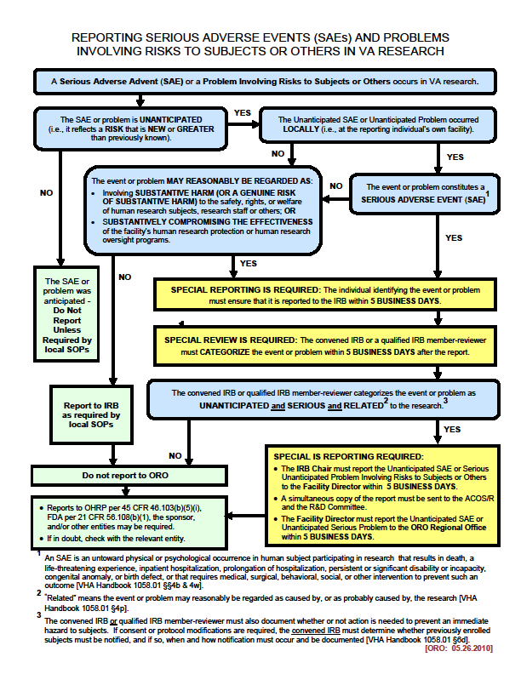

Decision chart for reporting noncompliance in VA research.